**Priority error in our live site which needs to be fixed**

1. When we are uploading new chart function with the previous existing then the new one is not working in indicator pages for example we tried with custom cleared trade. Removing the previous one then it works. We need to insert more than one interactive chart in an indicator page. The one we tried to do with custom cleared indicator page.
2. I think it is just an alignment issue to be get fixed in our live site. There is ‘No’ in bold letters which should be with ‘unlawful or prohibited use’.

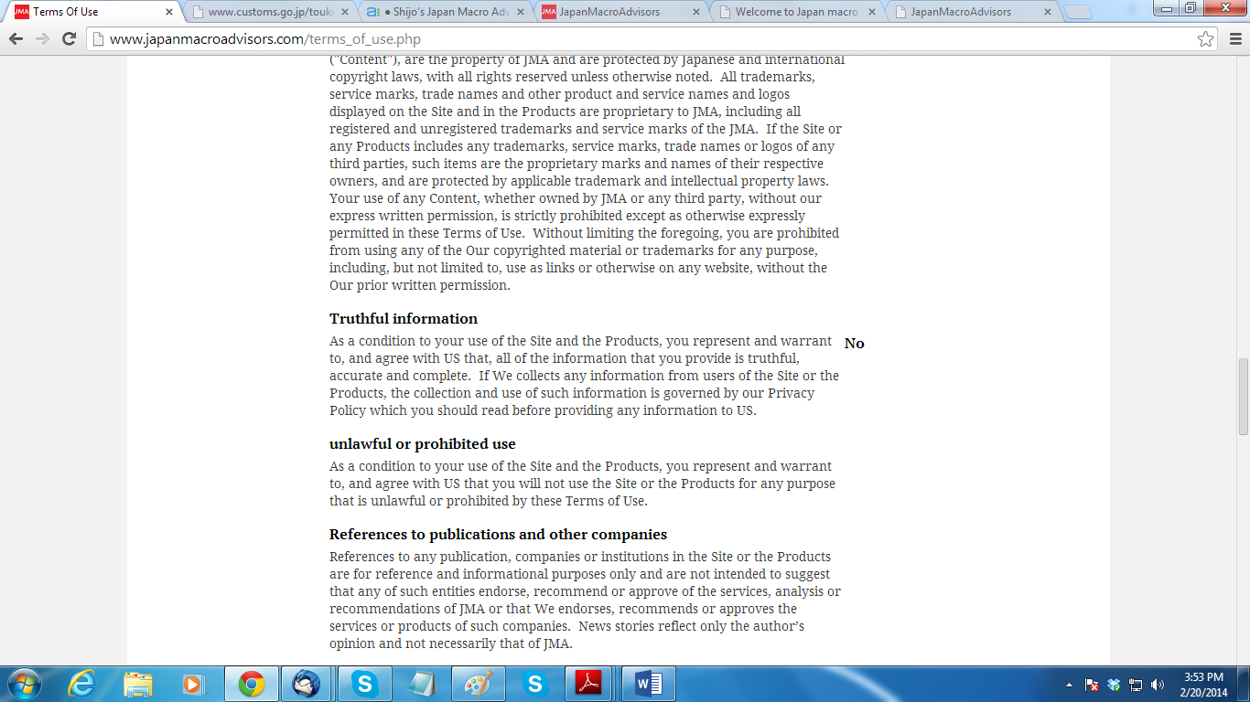

**Final list of errors in testing page**

1. When we click on print option in chart function, it fetches us the chart along with rest of the graph which we do not need if we want to print only chart function. To my notice, in some indicators the print preview fetch table as well.

Indicator pages with another chart: GDP, Industrial Production, Retail Sales, Custom-cleared trade.

Indicator Pages with tables: Balance of Payment, CPI, Bank Lending.

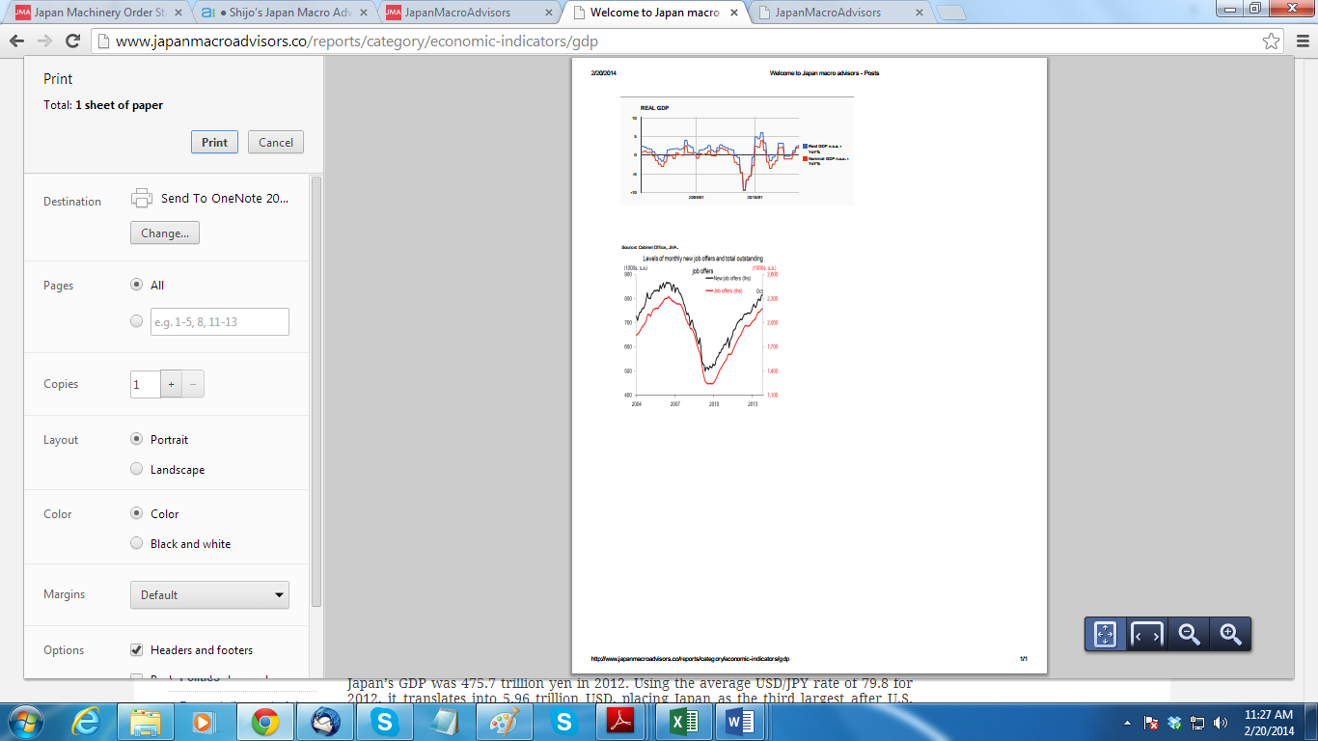

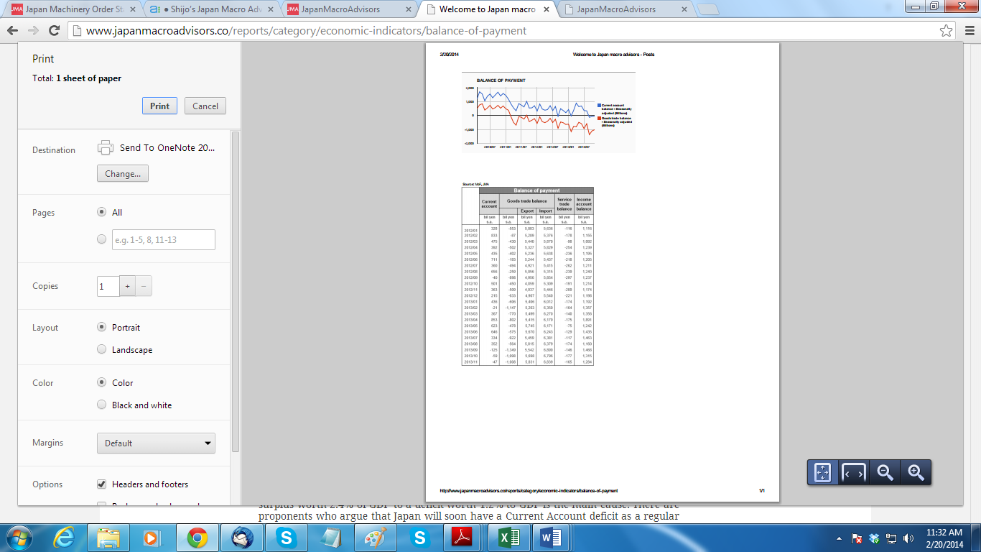

1. It seems that we are forcing them to change password by keeping it open. This change password is just required if they forget their password and we do not require to make it so open. We here had discussion over this and decided to put the change password option in box similar to the “Profile” above and we can put the edit option on the top right side exactly the way it is above in the “Profile”

See the image below:

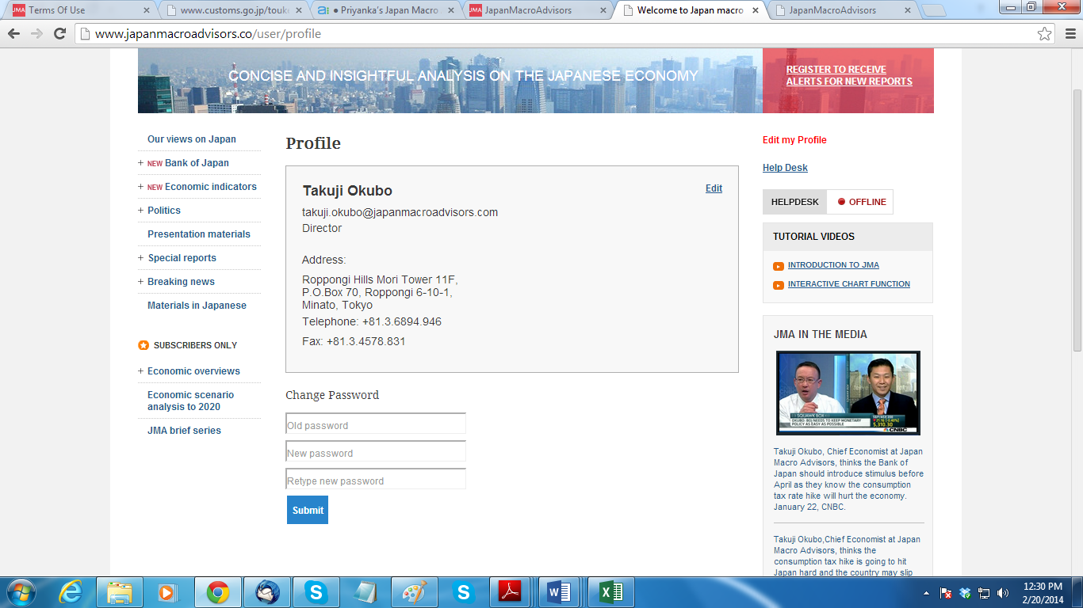

1. **One more issue is like when I click on forget password link it takes to a blank page showing page do not exist in below image.**

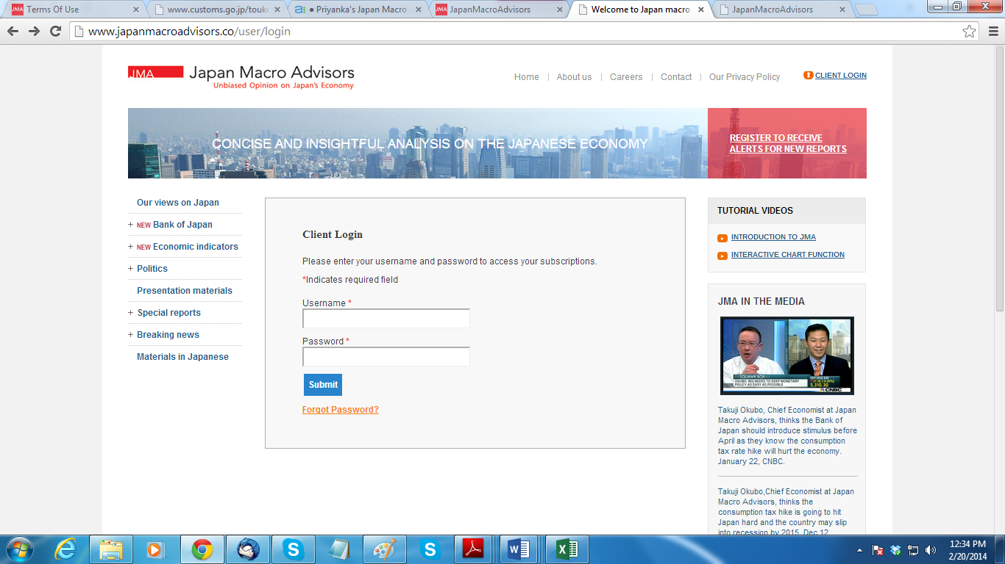

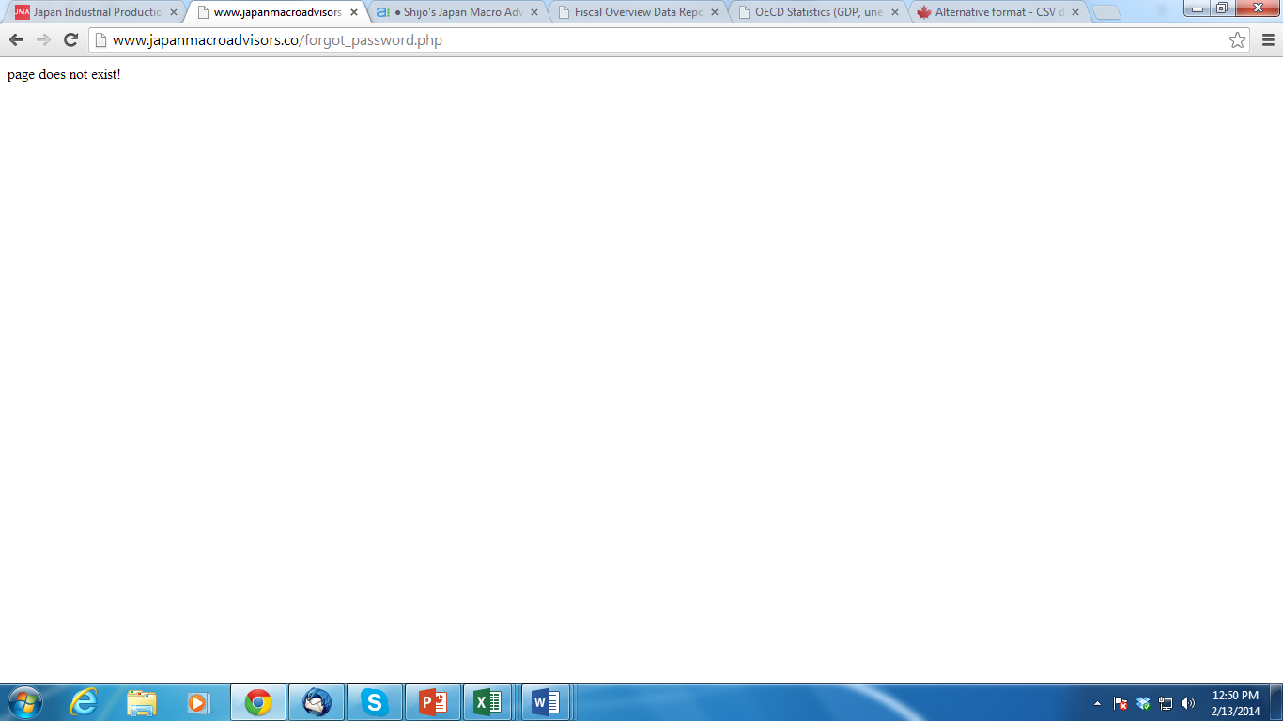

1. Here I can see just minor issue proper alignment of text that can be easily fixed as we re-upload the text.

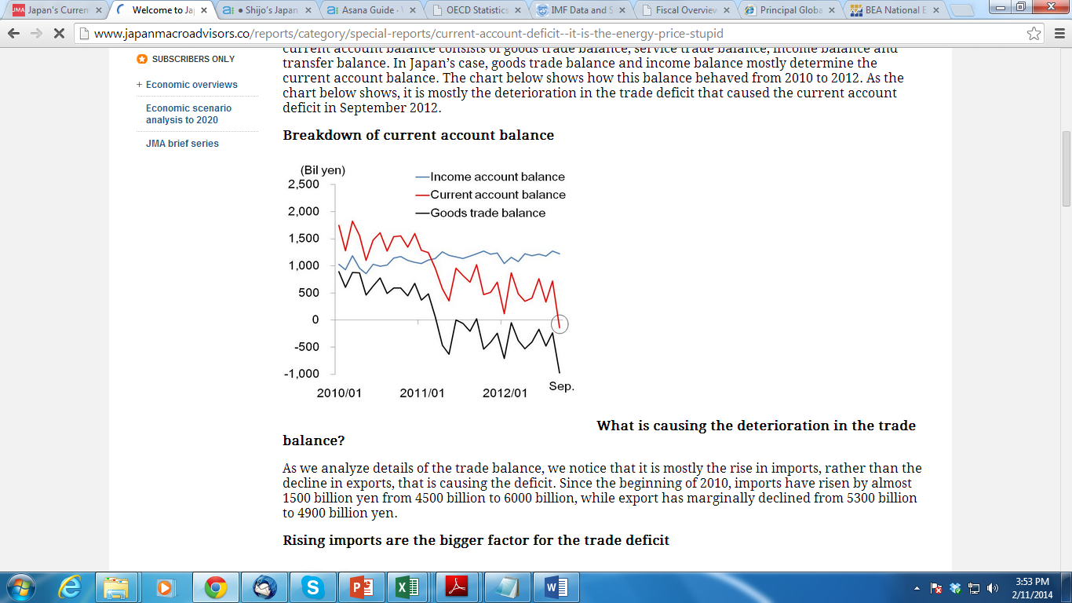

1. We also need edit settings for ID number as we already have for media section so that it would be easy for us to re-order the presentation materials (latest on the top).

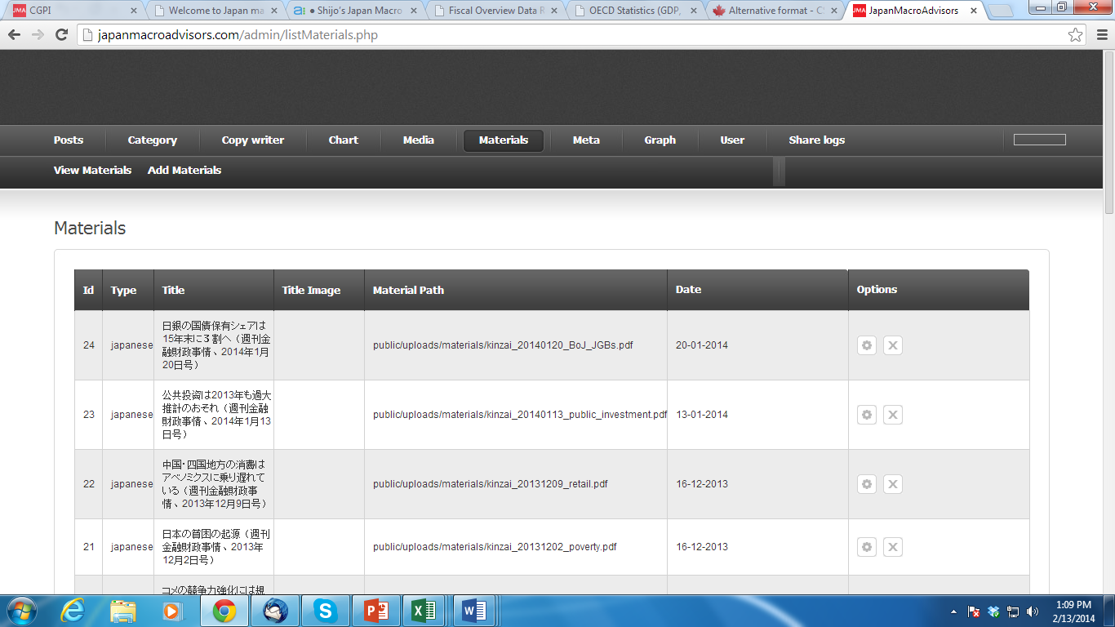

1. Hi team, we had a discussion today and came up with the idea of highlighting the chart function in the landing page of our website. We can have a program where the narrow chart of the economic indicator will show on the left hand side of the website just above the economic indicators. By doing so we can attract our client to the chart function which is one of the unique features of our website. A model of the same is shown in the below screen shot. We will redirect the customers to the full page once they click this image. We can also keep on changing the image whenever we have new update and this will help us to keep the updated image with the right chart for indicator. This requires an option at the back end to update the image and the link to the page with that chart function just like media option.

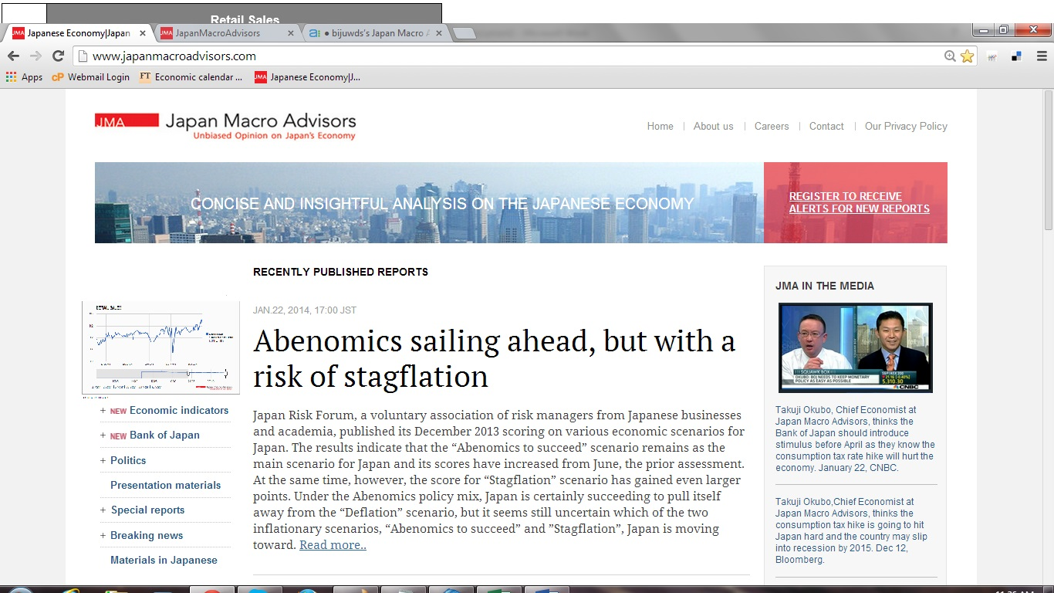

1. Can we separate the change password page from edit profile? This together is not looking good. It seems that we are forcing them to change password by keeping it open. This change password is just required if they forget their password and we do not require to make it so open. Please let me know if this is time consuming.
2. We can see broken image for the last presentation material shown below in the screenshot.

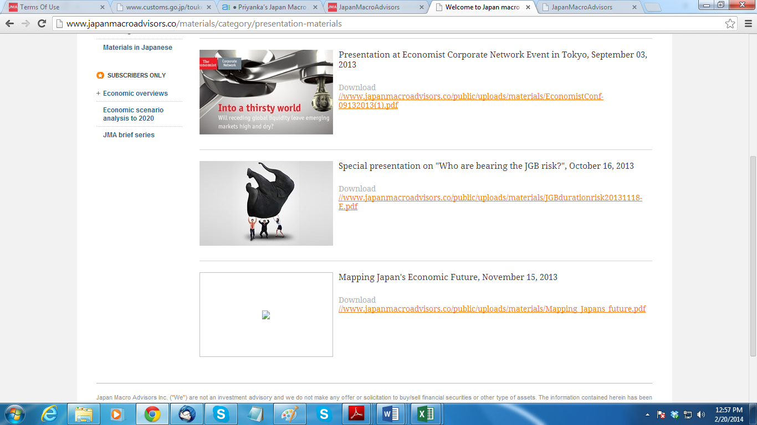

1. We also need edit id number option in our admin page to upload recent presentation material in a proper sequence order. As the latest report should be in descending date order.

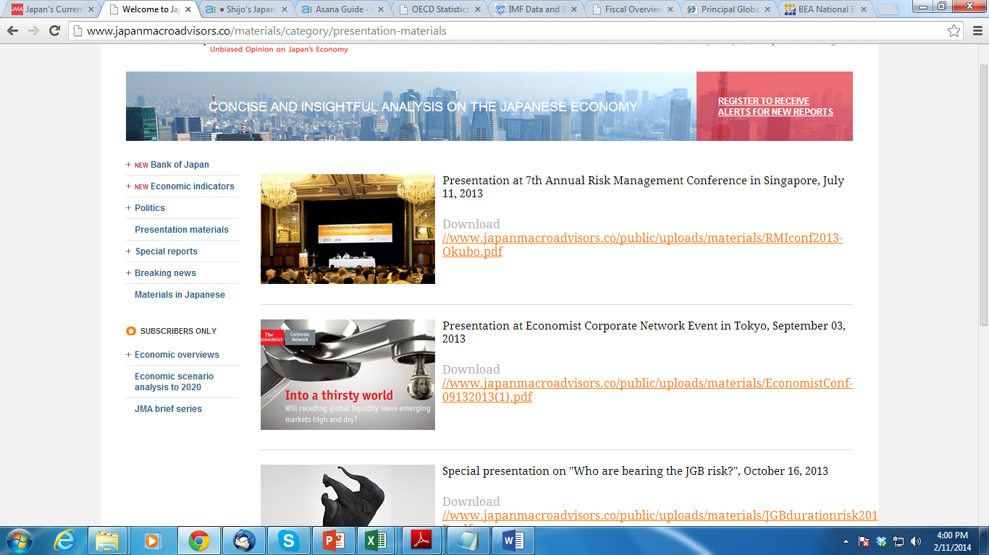

10) a) When we try to upload new media to the media section we can see broken picture.

b) Also we are unable to use the change date function shown in second image below.

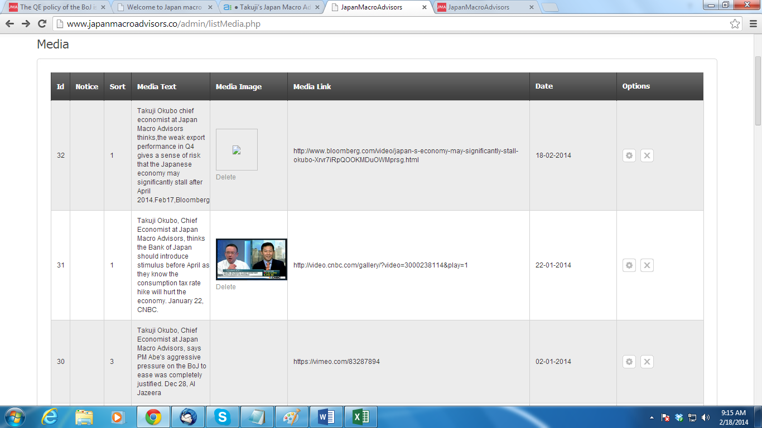

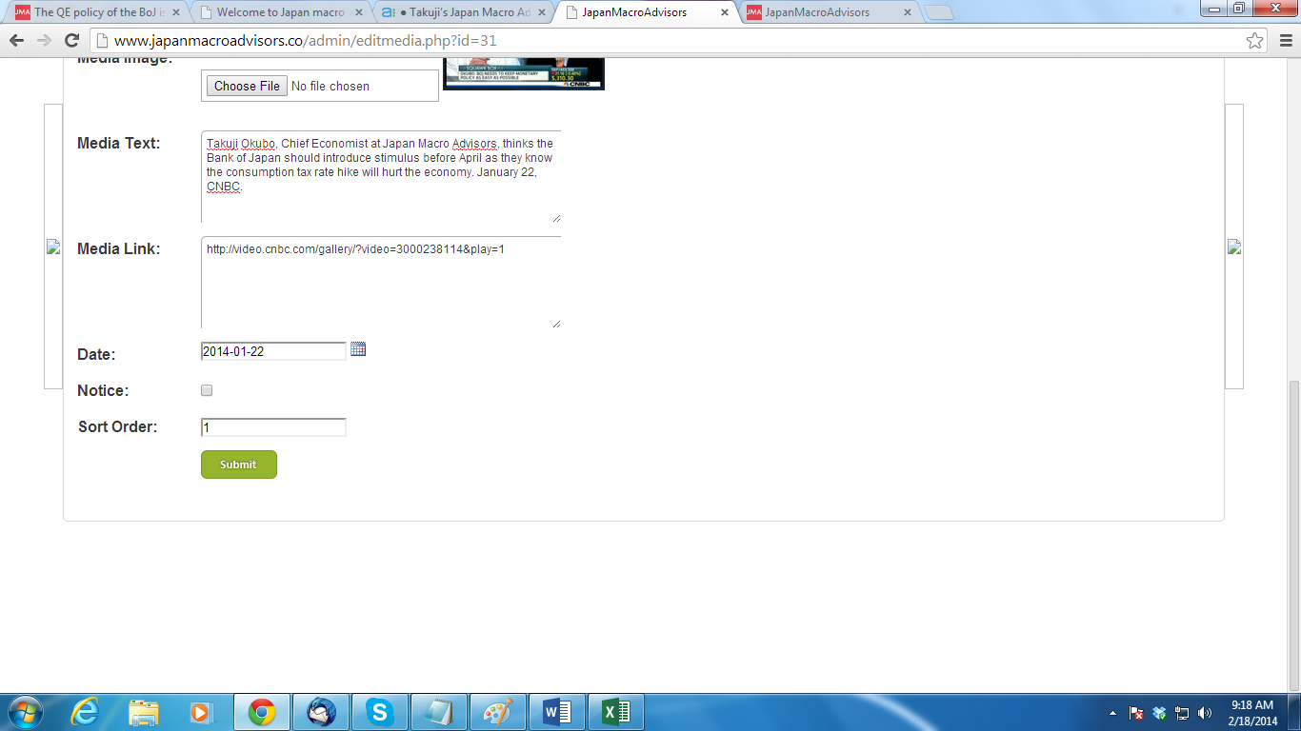

1. In the image below, we can see January calendar shown on the top left hand side of the testing admin page. We do not see error in our live site.

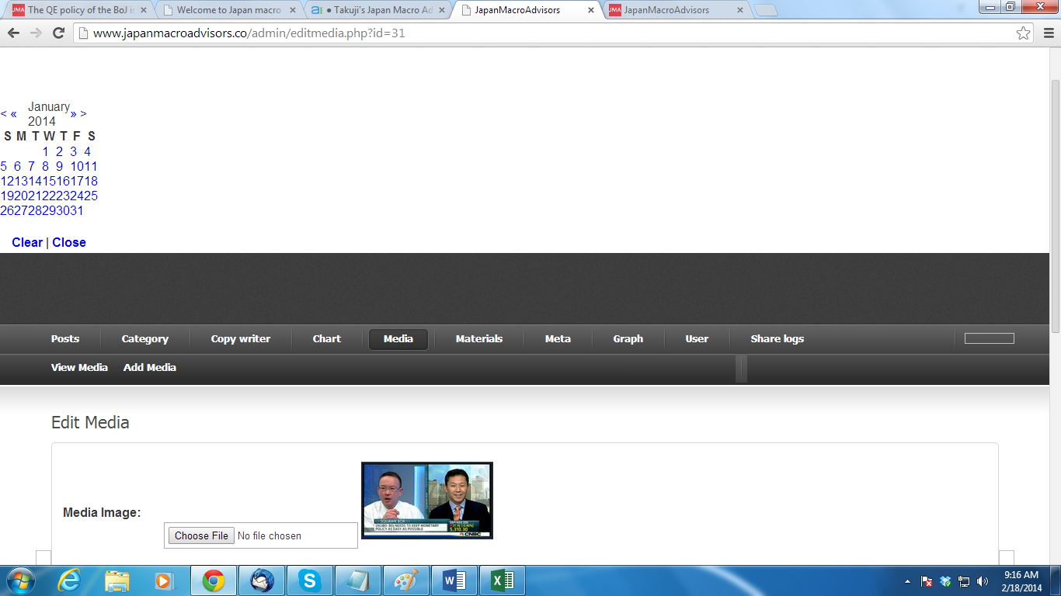

1. In the category section when we are making any post as “New” it is not reflecting in the testing site page under economic indicators as “New”.
2. Under Category section, we see the order number is not distinct rather same for all indicators which are under economic overviews.

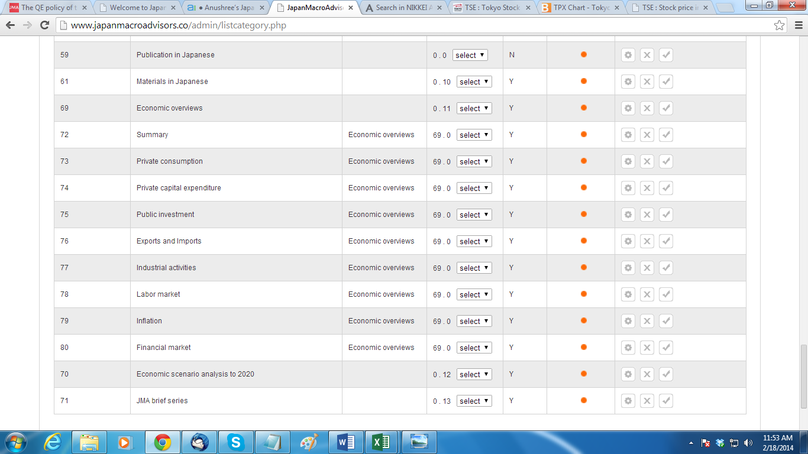

1. On ‘Our Views on Japan’ Page we cannot see the chart and table instead it is reflecting broken image and ‘r/n’ shown below in the screenshot.

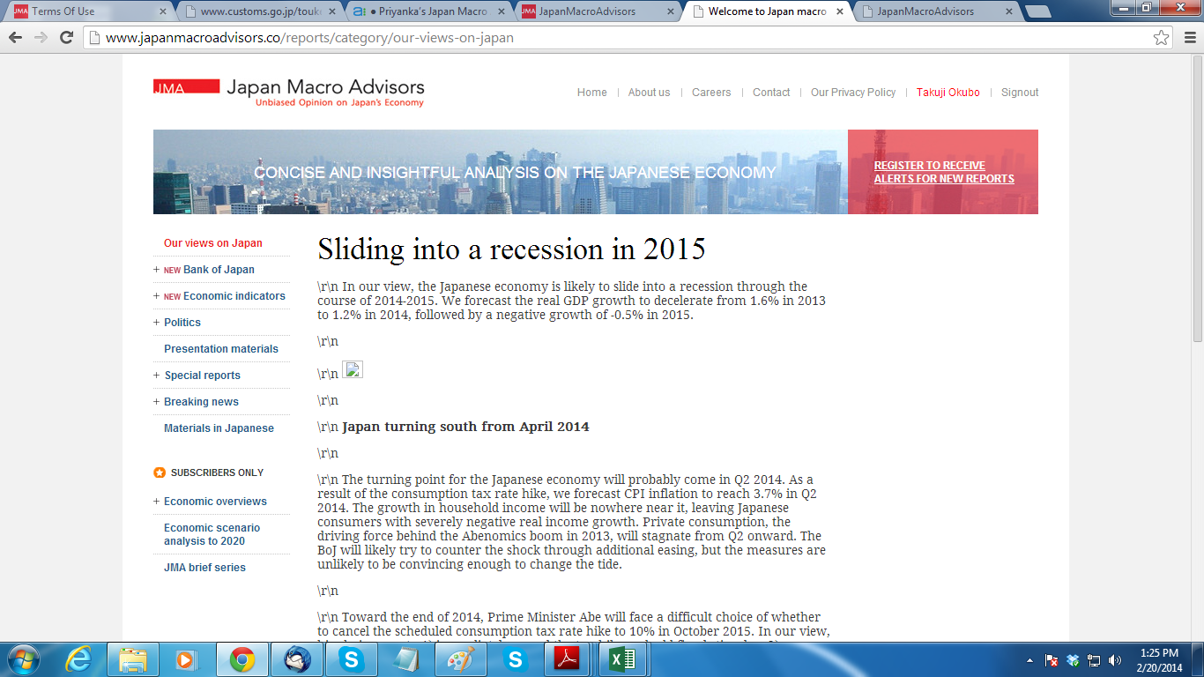

1. Under subscriber’s only section, we have economic overviews under which we have indicators like private consumption, private capital expenditure etc. When we click on share in the narrow interactive chart, the function does not work rather it reflects the dialog box below.

